SCHOOL

Year 12 Trial WACE Examination, 2013

Question/Answer Booklet

MATHEMATICS 3C/3D
SOLUTIONS

Section One:

Calculator-free

Student Number: In figures

In words

Your name

Time allowed for this section
Reading time before commencing work: five minutes
Working time for this section: fifty minutes

Materials required/recommended for this section

To be provided by the supervisor
This Question/Answer Booklet
Formula Sheet

To be provided by the candidate
Standard items: pens, pencils, pencil sharpener, eraser, correction fluid/tape, ruler, highlighters

Special items: nil

Important note to candidates

No other items may be used in this section of the examination. It is your responsibility to ensure that you do not have any unauthorised notes or other items of a non-personal nature in the examination room. If you have any unauthorised material with you, hand it to the supervisor before reading any further.

Structure of this paper

Section | Number of questions available | Number of questions to be answered | Working time (minutes) | Marks available | Percentage of exam
Section One:  Calculator-free | 8 | 8 | 50 | 50 | 33
Section Two:  Calculator-assumed | 13 | 13 | 100 | 100 | 67
 |  |  | Total | 150 | 100

Instructions to candidates

- The rules for the conduct of Western Australian external examinations are detailed in the Year 12 Information Handbook 2013. Sitting this examination implies that you agree to abide by these rules.

- Write your answers in the spaces provided in this Question/Answer Booklet. Spare pages are included at the end of this booklet. They can be used for planning your responses and/or as additional space if required to continue an answer.
- Planning: If you use the spare pages for planning, indicate this clearly at the top of the page.
- Continuing an answer: If you need to use the space to continue an answer, indicate in the original answer space where the answer is continued, i.e. give the page number. Fill in the number of the question(s) that you are continuing to answer at the top of the page.

- Show all your working clearly. Your working should be in sufficient detail to allow your answers to be checked readily and for marks to be awarded for reasoning. Incorrect answers given without supporting reasoning cannot be allocated any marks. For any question or part question worth more than two marks, valid working or justification is required to receive full marks. If you repeat an answer to any question, ensure that you cancel the answer you do not wish to have marked.

- It is recommended that you do not use pencil, except in diagrams.

Section One: Calculator-free (50 Marks)
This section has eight (8) questions. Answer all questions. Write your answers in the spaces provided.

Working time for this section is 50 minutes.

Question 1 (5 marks)
The price, $, of a commodity varied continuously with time, hours, according to the function 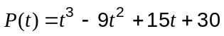 for 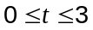.

Determine the lowest and highest price of the commodity.

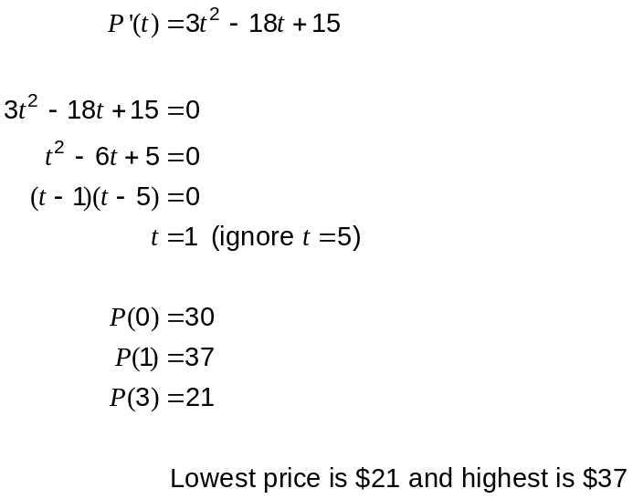

Question 2 (6 marks)
Differentiate each of the following with respect to , without simplifying.

(a) 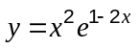 (2 marks)

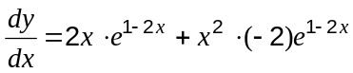

(b) 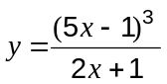 (2 marks)

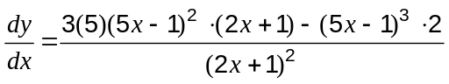

(c) 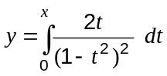 (2 marks)
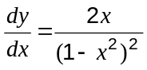

Question 3 (5 marks)
As part of a product recall, a shop removed all sizes of a variety of soup from its shelves. The soup was sold in 300 mL, 500 mL and 800 mL sizes for $4.50, $6.00 and $7.50 respectively. The total volume of soup in all 42 cans removed was 25 L and the value of these cans was to $267.

If 300 mL cans, 500 mL cans and 800 mL cans were removed, then some of the above information can be expressed by the equations 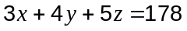 and 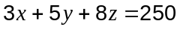.

Write down a third equation from the information and use it to find how many of each size of can were removed.
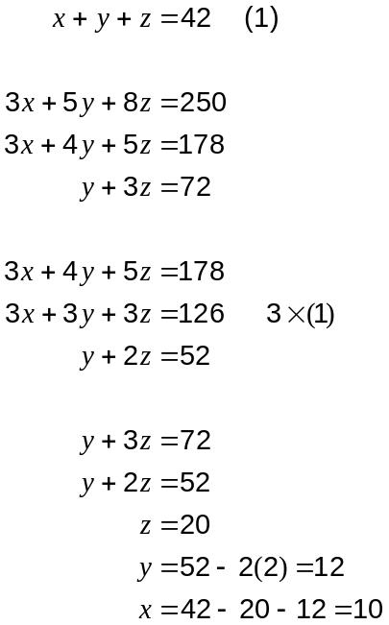

10 @ 300 mL, 12 @ 500 mL and 20 @ 800 mL.

Question 4 (5 marks)
(a) Determine 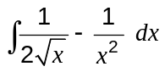 (2 marks)

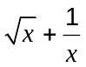

(b) If 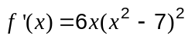 and 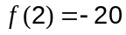, determine 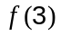. (3 marks)

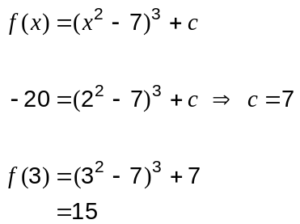

Question 5 (8 marks)
The events and have the properties 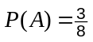 and 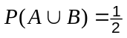.

(a) Determine 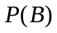 in each of these cases:

(i) If and are mutually exclusive. (1 mark)

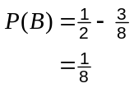

(ii) If 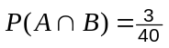. (2 marks)
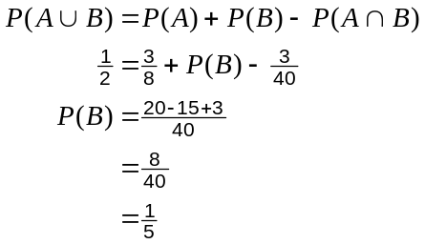

(iii) If 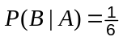. (3 marks)
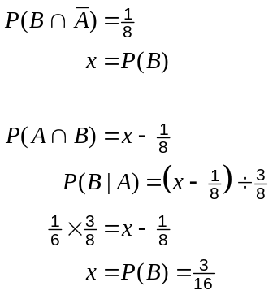

(b) For the case where , are and independent? Justify your answer.
(2 marks)
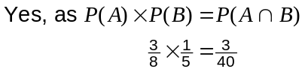

Question 6 (7 marks)
Let 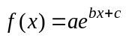, where , and are constants. The graph of 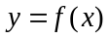 is shown below.
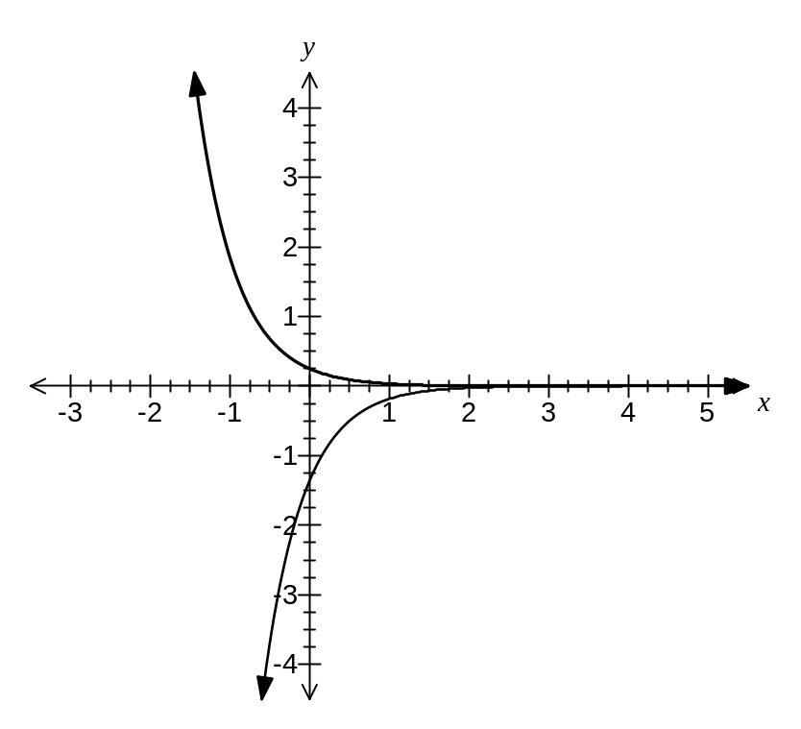
(a) Write down the range of

(i)  (1 mark)
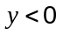

(ii) 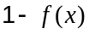 (1 mark)
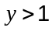

(b) The graph passes through the point 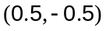. Explain why 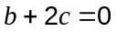 and hence state the value of and whether is positive or negative. (3 marks)
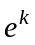 is irrational for all values of except 0. When 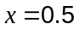, 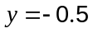 which is rational, so 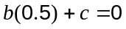 and so .

Hence 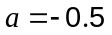.

The graph of 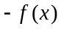 would show decay, thus must be negative and so must be positive.

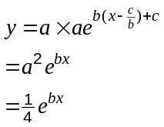

(c) Sketch the graph of 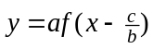 on the axes above. (2 marks)

Question 7 (6 marks)
(a) Write down the values of 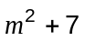 for 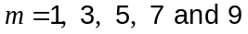. (1 mark)
8, 16, 32, 56, 88

(b) State the largest integer,, that is always divisible by, when is a positive odd integer. (1 mark)

The largest integer is 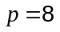

(c) Prove that is always divisible by when is a positive odd integer. (4 marks)

Let the positive odd integer 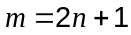, where is an integer greater than or equal to 0. Then:

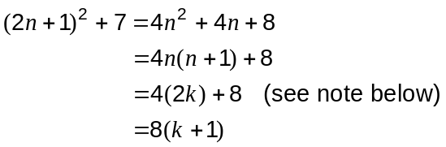

Hence the expression will always be divisible by eight.

Note: Since is an integer, then one of and 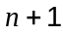 will be even and the other odd. Hence the product 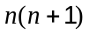 will have a factor of 2, and so 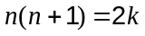, where is an integer greater than or equal to 0.

Question 8 (8 marks)
Two functions are defined by 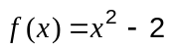 and 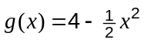. Their graphs are shown below.
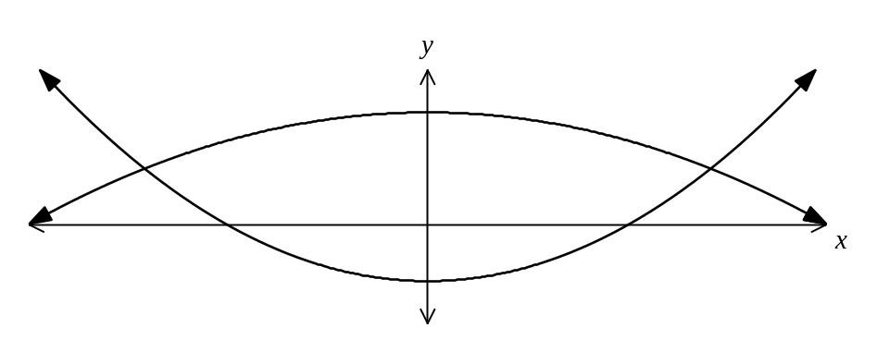

(a) State the coordinates of the minimum of and the maximum of 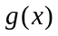. (1 mark)
(0, -2) and (0, 4)

(b) Find the coordinates of the points of intersection of and . (2 marks)
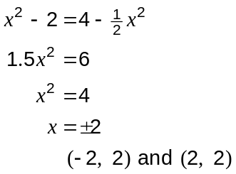

(c) The region enclosed by and is rotated about the -axis. Find the volume of the solid formed. (5 marks)
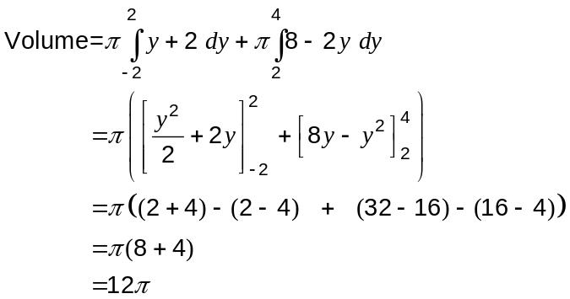

Additional working space

Question number: _________

This examination paper may be freely copied, or communicated on an intranet, for non-commercial purposes within educational institutes that have purchased the paper from WA Examination Papers provided that WA Examination Papers is acknowledged as the copyright owner. Teachers within purchasing schools may change the paper provided that WA Examination Paper's moral rights are not infringed.

Copying or communication for any other purposes can only be done within the terms of the Copyright Act or with prior written permission of WA Examination papers.

Published by WA Examination Papers
PO Box 445 Claremont WA 6910

